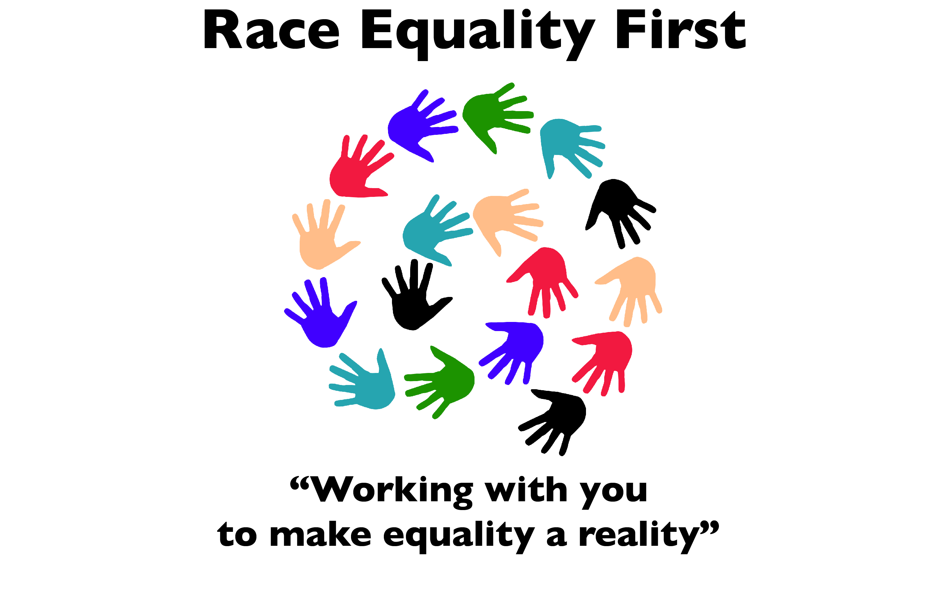
Race Equality First Membership Application Form:
For Affiliate Members (Organisations) and Personal Members (Individuals)
(Membership is open only to those who live or work in Cardiff and/or the Vale of Glamorgan)
Section 1
(*Please delete as appropriate)
I would like to apply for Affiliate/ Personal Membership of Race Equality First on behalf of:
Full Name (Organisation/Individual*)........................................................................................
Address........................................................................................................................................
Postcode.............................Telephone No:............................................Fax................................
Email.........................................................................................
Section 2: Declaration
I understand that the objects of Race Equality First are:
- To work towards the elimination of racial discrimination;

And

- To promote equality of opportunity, and good relations, between persons of different racial groups;

Especially in counties of Cardiff and Vale of Glamorgan.

I/we declare that I/we are committed to the above stated objects of Race Equality First and to working their fulfilment.
I confirm that I/we* are committed to the above stated objects of Race Equality First and to working towards their fulfilment.
I confirm that I/we* are not a member of any other race equality council.
I/we* understand that my / our membership of race Equality First is initially for a period of three years from the date of acceptance, at the end of which , should we wish to renew our membership , I/we will be required to reaffirm in writing our commitment made above.

Signature..................................................Date.............................
On Behalf of..................................................................................
Section 3
Race Equality First receives many requests from organisations and individuals who would like who would like to contact our members. If you membership application is successful please indicate whether you would be willing for your contact details to be give out to such third parties by ticking the relevant box below.
I agree that my contact details may be given out to third parties

I do not agree that my contact details may be given out to third parties
Section 4
To be completed by Affiliate (Organisation) applicants only.
If our organisation is accepted as an Affiliate Member, its nominee to serve as voting members of the Race Equality First will be:
Name (Mr/Mrs/Miss/Ms) ..............................................................................................................................
Address.................................................................................................................................................................................Postcode...................................Telephone no..........................................................................
E- Mail ...........................................................................................................................................................
- When was your organisation formed ...............................................................................................

- If appropriate, how many members do your organisation.............................................................
Currently have?
Please note: if appropriate an affiliate member must provide evidence in writing its organisation has bonefide membership scheme. If an organisation employs staff or provide services it must provide a copy of its equal opportunities policy.

Please return competed form to:
Sang-Jin Park, Race Equality First, 113-116 Bute Street, Cardiff CF10 5EQ

*************************************************************************************
OFFICE USE ONLY:
Date received ......................................................................... Date approved.......................................

